Lesson 5 Demo 1: Set up a Swarm Cluster with a Manager and Worker Node

This section will guide you to:

* Set up a swarm cluster with a manager and worker node

**Step 1**: Create a swarm cluster and join the manager and worker node

* On the master node, initialize the swarm

*sudo docker swarm init*

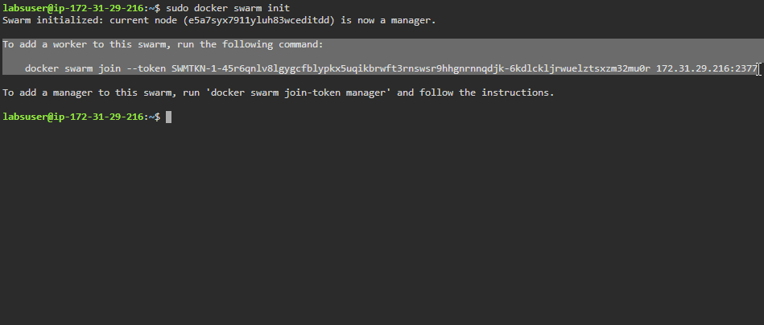

* Click on the **worker1** tab on the lab and navigate to the newly opened browser tab



* On **worker1,** join the swarm as a **worker node** using the***sudo docker swarm join***command provided in the first step

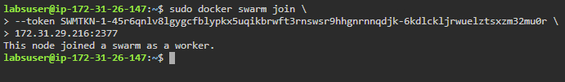

* Navigate back to the **master** node and list all the nodes of the swarm cluster

*sudo docker node ls*

